Project Design Phase
Solution Architecture
Project Name: Emotion Detection and Learning Support Engine
Team ID: SWTID-2026-2247
Date: 07 July 2026
Maximum Marks: 4 Marks

1. Introduction
The Emotion Detection and Learning Support Engine is an intelligent educational platform designed to observe, interpret, and respond to a learner's emotional state during a study session. Unlike conventional e-learning systems that treat every learner identically regardless of how engaged, confused, or fatigued they are, this system continuously senses affective signals such as facial expression, vocal tone, typing rhythm, and response latency, and converts them into a real-time emotional profile. This profile is then used to adapt the pace, difficulty, and delivery style of the learning content, so that the platform behaves more like an attentive human tutor than a static content repository.
Solution architecture, in the context of this project, is the blueprint that connects the business problem of disengaged or struggling learners with a concrete technical solution. It defines how sensors, machine learning models, decision engines, and content delivery layers interact, and it gives project stakeholders a shared, unambiguous picture of what is being built and why.

1.1 Purpose of the Solution Architecture
- Translate the problem of low learner engagement into a well-defined, implementable technical design.
- Describe the structure, behaviour, and responsibilities of every module in the system.
- Establish clear interfaces between the emotion sensing layer, the intelligence layer, and the content delivery layer.
- Provide a specification that guides development, testing, and future scaling of the platform.

2. Problem Statement
Traditional online learning platforms deliver identical content regardless of a learner's real-time cognitive and emotional state. A student who is confused receives the same pace of instruction as one who is bored, and a student who is frustrated is rarely offered a simplified explanation or a short break before disengagement turns into drop-off. This lack of emotional awareness leads to reduced retention, lower course completion rates, and an overall learning experience that fails to adapt to the individual. There is a clear need for a system that can detect emotional and cognitive states unobtrusively and translate them into timely, personalised interventions.

3. Proposed Solution Overview
The proposed system continuously captures multimodal signals from the learner through a webcam, microphone, and interaction patterns such as keystrokes, mouse movement, and quiz response times. These raw signals are cleaned and converted into meaningful features, which are then passed to a fusion-based emotion classification model. The model determines whether the learner is in a state such as engaged, confused, bored, anxious, or frustrated. Based on this state, the Learning Support Engine selects an appropriate pedagogical strategy, for example slowing down the pace, offering a simpler explanation, inserting a short motivational break, or switching to a different content format such as a video instead of text.
The architecture is designed to be modular, so that the emotion sensing component, the classification model, and the content adaptation logic can each be improved or replaced independently without disturbing the rest of the system.

4. High-Level Architecture
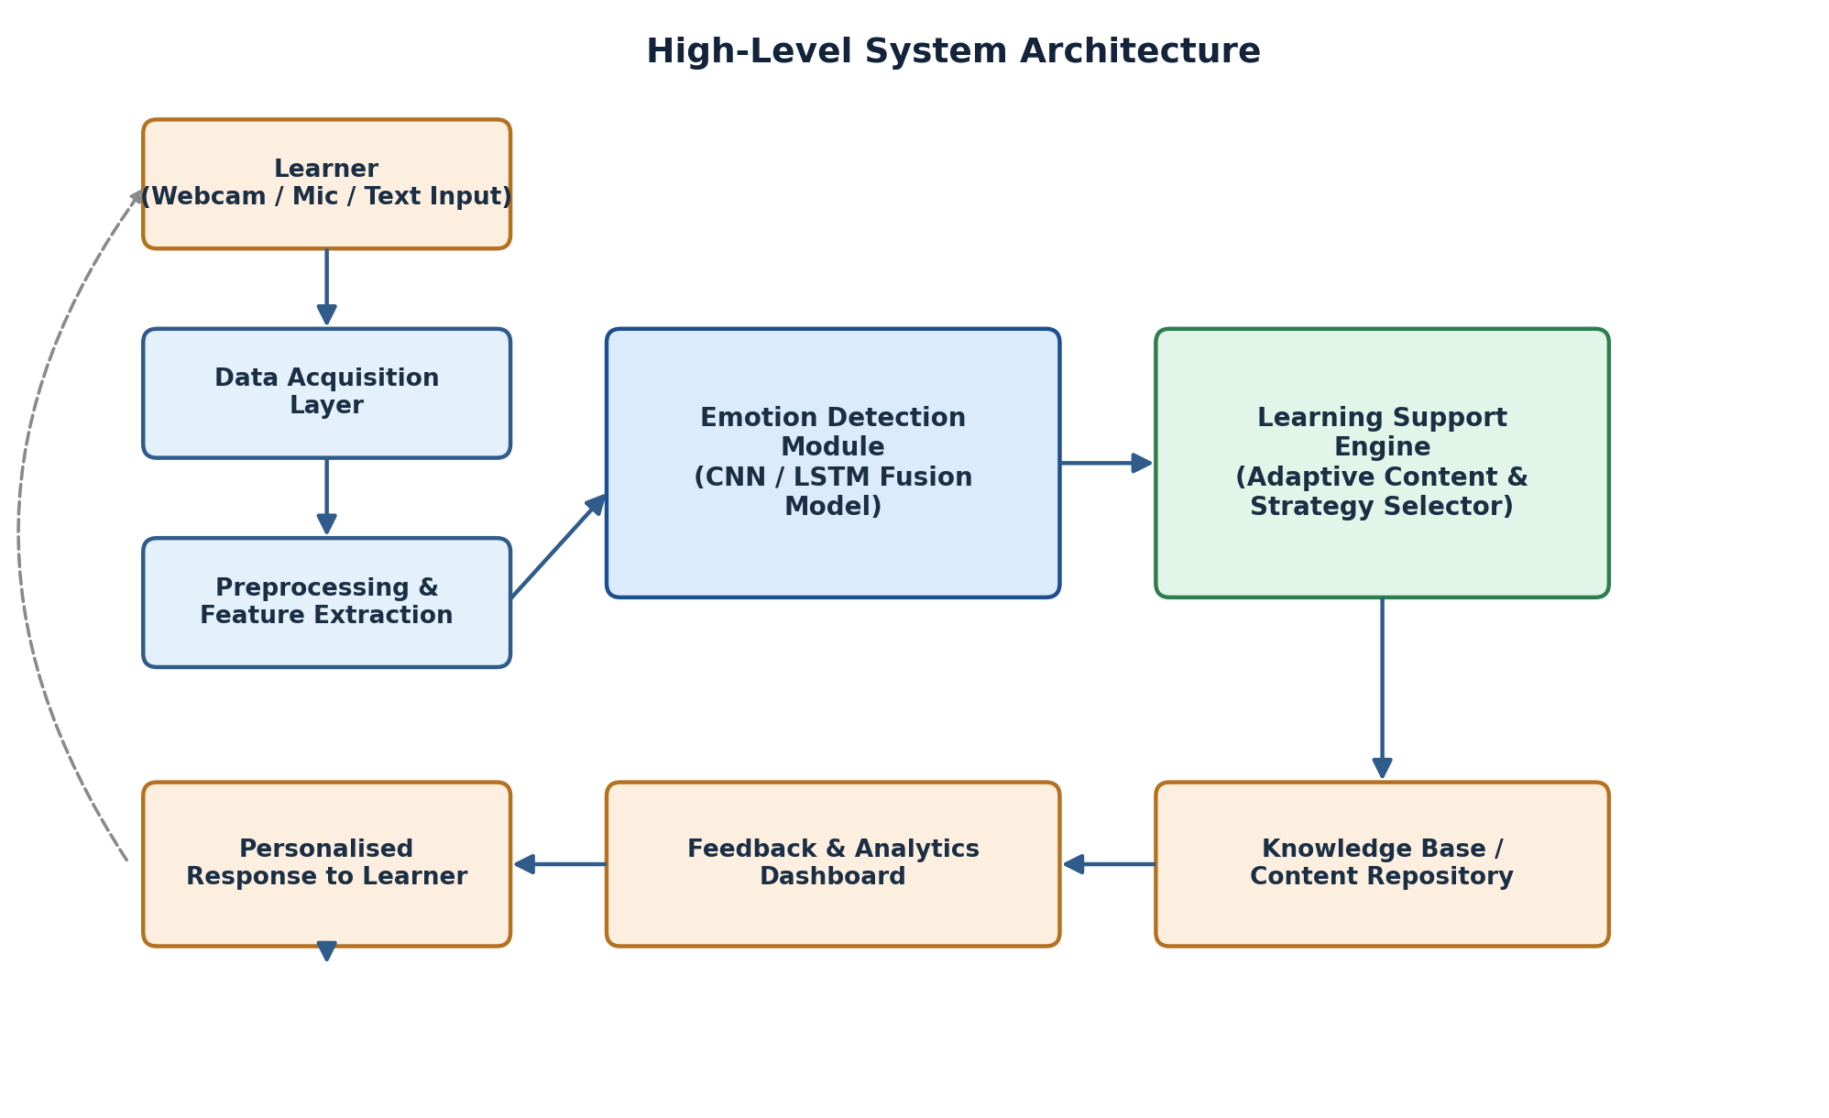
Figure 1: High-level system architecture of the Emotion Detection and Learning Support Engine
The architecture is organised into distinct layers. The learner interacts with the system through a webcam, microphone, or text interface. Raw signals move through a data acquisition layer into a preprocessing stage where noise is removed and relevant features are isolated. The Emotion Detection Module, built on a fusion of convolutional and recurrent neural network components, analyses these features to infer the learner's affective state. This inference is passed to the Learning Support Engine, which consults a knowledge base and content repository to select the most suitable instructional response. The outcome is delivered back to the learner as a personalised response, while a feedback and analytics dashboard records the interaction for continuous improvement of the system.

5. Architecture Layers

5.1 Data Acquisition Layer
This layer is responsible for capturing raw signals from the learner in a non-intrusive manner. It gathers video frames from the webcam for facial expression analysis, audio samples from the microphone for vocal tone analysis, and behavioural data such as keystroke intervals, mouse movement, and quiz response latency. All capture happens with the learner's consent and is designed to run in the background without interrupting the learning session.

5.2 Preprocessing and Feature Extraction Layer
Raw signals are rarely usable in their original form. This layer applies noise filtering, face and voice activity detection, normalisation, and dimensionality reduction. From video, facial landmarks and action units are extracted; from audio, pitch, energy, and speaking rate are computed; from text and interaction logs, response time and error patterns are derived. The output is a compact, well-structured feature vector for each modality.

5.3 Emotion Detection Module
The core intelligence of the system lies in this module, which fuses the facial, vocal, and behavioural feature vectors using a multimodal fusion network. A convolutional neural network processes the visual stream, a recurrent or transformer-based network processes the temporal audio and behavioural streams, and a fusion layer combines these representations to output a probability distribution across emotional and cognitive states such as engaged, confused, bored, anxious, and frustrated.

5.4 Learning Support Engine
Once an emotional state is inferred, the Learning Support Engine decides how the platform should respond. It applies a rule-based and machine-learning-assisted decision policy that maps emotional states to instructional actions, for instance triggering a simplified explanation when confusion is detected, introducing a gamified activity when boredom is detected, or offering a short break when frustration persists across several attempts. The engine draws on a knowledge base of alternative content formats and pedagogical strategies to personalise its response.

5.5 User Interaction and Feedback Layer
This layer presents the adapted content back to the learner and simultaneously logs the interaction outcome. A feedback and analytics dashboard is made available to instructors, allowing them to review aggregated emotional trends across a class and identify learners who may need additional support. This closes the loop between sensing, decision-making, and real-world instructional impact.

6. Data Flow Design
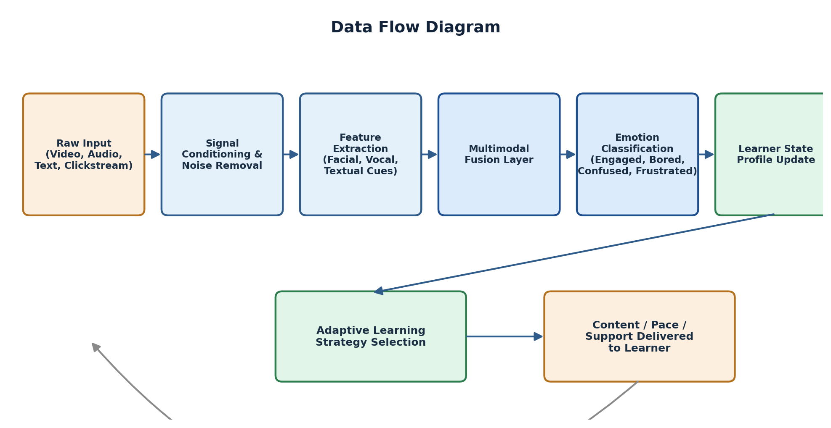
Figure 2: Data flow across the sensing, classification, and adaptation pipeline
Data flows through the system in a well-defined sequence. Raw input from video, audio, text, and clickstream sources is first conditioned to remove noise. Relevant features are then extracted for each modality and passed through a multimodal fusion layer, which produces a unified representation of the learner's state. This representation is classified into an emotional category, and the result updates a running learner state profile. The Learning Support Engine reads this profile to select an adaptive strategy, which determines the content, pace, and level of support delivered to the learner. Outcomes are fed back into the learner state profile, allowing the system to refine its understanding over time.

7. Technology Stack
- Frontend: React based web interface with a lightweight video and audio capture module.
- Backend: Python with FastAPI for serving the emotion detection and recommendation models.
- Machine Learning: TensorFlow or PyTorch for the CNN and LSTM based fusion model.
- Data Storage: PostgreSQL for learner profiles and MongoDB for unstructured interaction logs.
- Deployment: Docker containers orchestrated on a cloud platform such as AWS or Google Cloud.
- Monitoring: A dashboard built with a charting library to visualise emotional trends for instructors.

8. Advantages of the Proposed Architecture
- Modular design allows each layer to be upgraded independently as better models become available.
- Real-time adaptation improves learner engagement and reduces drop-off during difficult topics.
- Multimodal fusion increases the reliability of emotion detection compared to a single-signal approach.
- Instructor-facing analytics provide actionable insight into class-wide emotional and learning trends.
- The architecture is scalable and can be extended to new content types and additional sensing modalities.

9. Conclusion
The Emotion Detection and Learning Support Engine architecture presented here provides a structured pathway from raw affective signals to meaningful, personalised instructional action. By combining a robust data acquisition and preprocessing pipeline with a multimodal emotion detection model and an adaptive learning support engine, the system is able to respond to learners in a way that mirrors the responsiveness of a human tutor. This design forms a strong foundation for the subsequent implementation and testing phases of the project.

